Saving File

Save Info
# Source: Person Source: Provided by: [Data Path: Persons Table -> ID Column: 1, Name_En Column: Motasem Essam] Written by: [Data Path: Persons Table -> ID Column: 1, Name_En Column: Motasem Essam] on [11/7/2025]
Save Emulator: PC
Save Type: Folder

Save Location
# Source: ScreenShot Source: Provided by: [Persons Table -> ID Column: 1, Name_En Column: Motasem Essam] -> Tool: [Automation Table -> ID Column: 16, Name_En Column: Screen Capture] -> From [Operating System: Windows] on [5/27/2026]
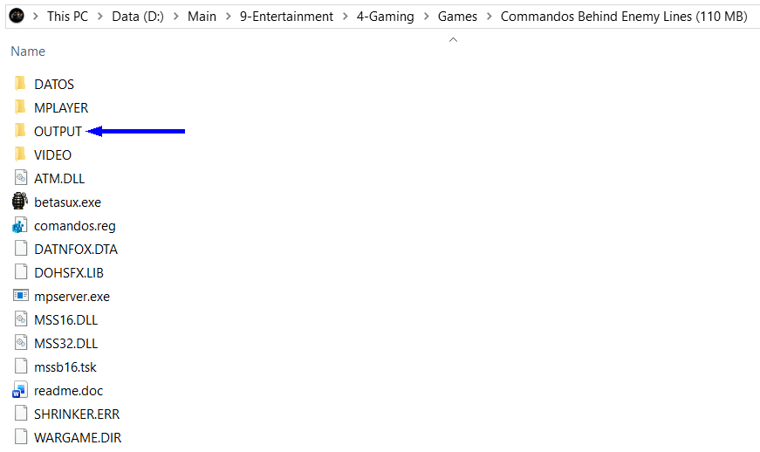
Compress output Folder to make save

